Classical Mechanics

Problems

Measurement

Position

Momentum

Center of Mass
1. Given an object composed of 16 circles, randomly arranged in a (n x n) grid, determine
2. What is it's mass?
3. What is it's center along each axis (x, y)?
4. What is it's center of mass?
5. What changes if the mass of each circle differs?

5. Given an object composed of 16 circles, randomly arranged in a (n x n) octagon grid, determine
6. What is it's mass?
7. What is it's center along each axis (x, y)?
8. What is it's center of mass?
9. What changes if the mass of each circle differs?

10. Given an object composed of 16 spheres, randomly arranged in a 3D (n x n x n) grid, determine
11. What is it's mass?
12. What is it's center along each axis (x, y)?
13. What is it's center of mass?
14. What changes if the mass of each circle differs?

Density
1. Given the density (p) of 2x, what is the mass (M) for a length (L)?
2. What is the center of mass (x) for the length (L)?

3. Given a string who's density changes according to F(x), what is the mass (M) for a length (L)?
4. What is the center of mass (x) for the length (L)?

5. Given object that fits into a cube, describe how you would calculate the density of the object?
6. Describe how you would find it's center of mass?

Reduce Mass
Calculate the reduced mass for each of the masses presented in Center of Mass and Density

Elastic and Inelastic Collisions

Physical State

Kinetic Energy

Potential Energy

Least Action Principle

GoldStein

Questions
1. What is the amplitude of the curve when the ball is thrown?

2. What equations were used to calculate the path of the ball with and without additional forces?

3. How does the number of divisions affect your calculations?

4. Can momentum be negative?

5. Why is the velocity so much smaller than the momentum?

6. If you changed the height of the ball thrown, how does this affect the velocity and momentum?

7. What is the continuum limit?

8. What is the set of points needed to describe motion in a 1D environment?

9. What are the set of points needed to describe motion in 3D environment?

10. What does the initial momentum need to be to travel a specific path and return to the starting point at time (t)?

Questions
1. What is an action function?

2. What set of points is described by the action function?

3. What is the principle of least action?

4. What is a stationary state?

5. Describe what is happening in equations 40 - 47?

6. How is an action function and a trajectory related?

Questions
1. What is a parametric function?

2. Think of two functions that meet at a point at P(x,y).

3. Find the tangent vectors of S and R at point P.

Questions

1. What is the Lagrangian Function?

2. What does the motion of a ball through the air look like as a Lagrangian function?

3. How is momentum related to position?

4. Why is momentum a second order derivative of the Lagrangian?

5. What is does the 1st order derivative of the Lagrangian represent?

Questions

1. Two point-like particles moving in three dimensions have masses m1 and m2 respectively, and interact via a potential V (x1 − x2). Find Hamilton’s equations of motion for the particles.

2. Suppose, instead of a rigid rod, the mass of the plane pendulum is connected to point P by a weightless spring. The potential energy of the spring is

PE = 1 /2 k (L − L0 )^2 ,

L .. is the length of the spring, and
L0 .. is its length when not displaced by an external force.

Choosing L and θ as the generalized coordinates, find Hamilton’s equations.

Example: Ball thrown into the air
1
0
2
Figure 2 - A ball being thrown through the air with the direction of travel indicated by the path vector.

Figure 3 - Graph of height, velocity, and momentum of the ball when thrown into the air.

Figure 3 - toss of ball's height over time divisions using 2 different methods to calculate it's height.

Using XL or Python
Create a table with the columns: time, height, momentum, and velocity
For height 1 use .. -x^2 ..
For height 2 use .. sin (x) ..
Adjust the equations accordingly so that the maximum height of the ball toss is at N / 2
N .. is the number of rows used to calculate the position of the ball over time.
To improve the data, account for the force used to accelerate the ball into the air, and the forces acting on the balls accent and decent.
Produce 1 or more graphs of the tosses
Estimate the weight of the ball being tossed.

Recall ..

Momentum is a vector
toRadians (nDegrees) = nDegrees * π / 180
toDegrees (nRadians) = nRadians * 180 / π

Questions
1. What is the amplitude of the curve when the ball is thrown?

2. What equations were used to calculate the path of the ball with and without additional forces?

3. How does the number of divisions affect your calculations?

4. Can momentum be negative?

5. Why is the velocity so much smaller than the momentum?

6. If you changed the height of the ball thrown, how does this affect the velocity and momentum?

7. What is the continuum limit?

8. What is the set of points needed to describe motion in a 1D environment?

9. What are the set of points needed to describe motion in 3D environment?

10. What does the initial momentum need to be to travel a specific path and return to the starting point at time (t)?

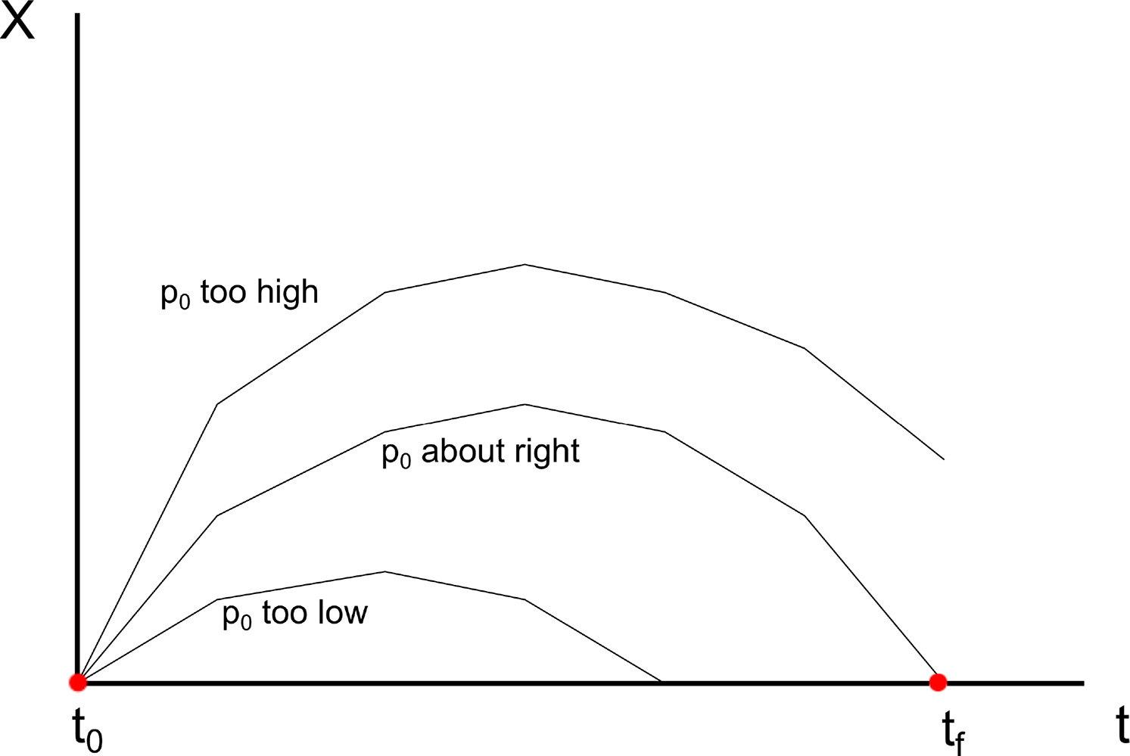
Figure 4 - demonstration of various tragectories to reach (t [Final]).

Principle of Least Action

1. What is an action function?

2. What set of points is described by the action function?

3. What is the principle of least action?

4. What is a stationary state?

5. Describe what is happening in equations 40 - 47?

6. How is an action function and a trajectory related?

Lagrangian Review

S
R
A
B
r
P
Figure 5 - shows the curves of (S and R) meeting at point (P), with the vectors (A and B) pointing perpendicular to the tangent of the lines.

Questions
1. What is a parametric function?

2. Think of two functions that meet at a point at P(x,y).

3. Find the tangent vectors of S and R at point P.

4.

Euler–Lagrange and Hamilton’s equations
The Lagrangian equation looks to balance the Kinetic Energy (KE) against the Potential Energy (PE) or V(x), so that the resulting force are in equilibrium, KE = PE or KE - PE = 0.

Questions

1. What is the Lagrangian Function?

2. What does the motion of a ball through the air look like as a Lagrangian function?

3. How is momentum related to position?

4. Why is momentum a second order derivative of the Lagrangian?

5. What is does the 1st order derivative of the Lagrangian represent?

Hamiltonian
The Hamiltonian is the sum of the Kinetic Energy (KE) and the Potential Energy (PE) or V(x). When evaluated with respect to the Lagrangian, ...

Questions

Classical Mechanics in a NutShell
Let's review, generalize and abstract the previous sections to build a strategy that allows us to produce the generalized Hamiltonian equations of motion.

Questions

Example: Pendulum

Questions

The Classical State

Questions

Problems

1. Two point-like particles moving in three dimensions have masses m1 and m2 respectively, and interact via a potential V (x1 − x2). Find Hamilton’s equations of motion for the particles.

2. Suppose, instead of a rigid rod, the mass of the plane pendulum is connected to point P by a weightless spring. The potential energy of the spring is

PE = 1 /2 k (L − L0 )^2 ,

L .. is the length of the spring, and
L0 .. is its length when not displaced by an external force.

Choosing L and θ as the generalized coordinates, find Hamilton’s equations.

